Q. Enumerate PMBOK Knowledge Areas.

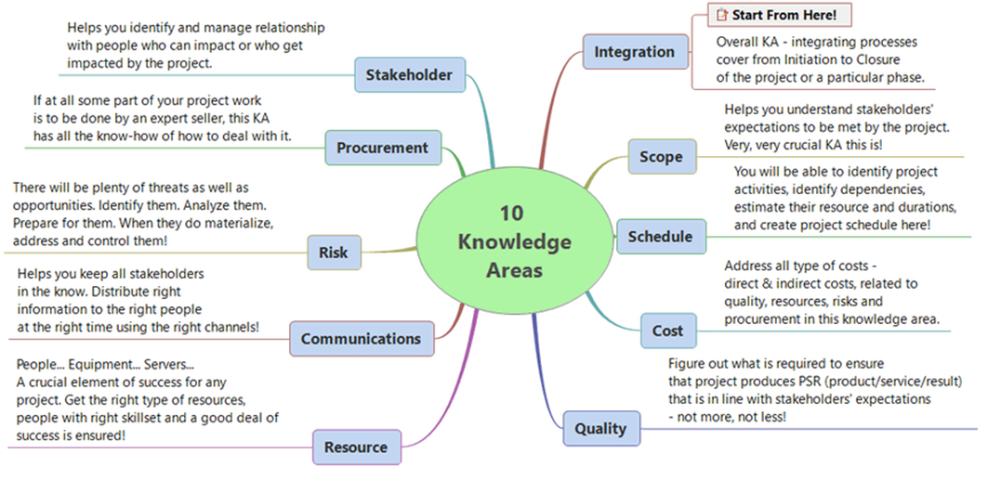

Understanding 10 Knowledge Areas

Q. Draw AON and AOA diagram for

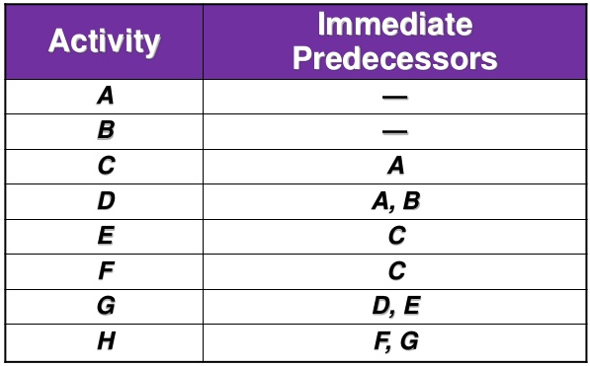

Answer:

**Activity on Arrow**

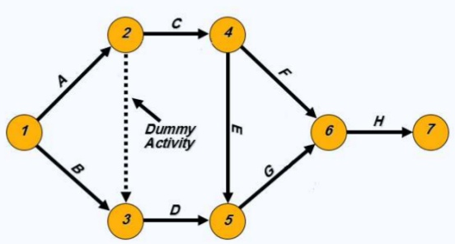

**Activity on Node**

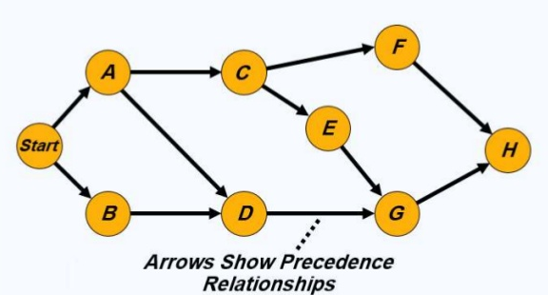

**Q.** A project manager and team came up with the estimates as presented in table. Draw an Activity on Node diagram, calculate expected duration for each activity and calculate and find the crtitical path.

Table : Activity Analysis for PERT



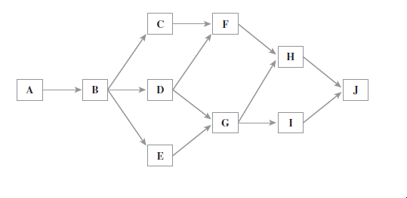**Answer :** Activity on Node Diagram

Expected Duration Calculation



**Critical Path Calculation**

Possible PERT Activity Paths



Path 4 is critical path with 21 days duration.